# **Surveillance System**

### **A PROJECT REPORT**

### ***Submitted by***

**Ishit Pragnesh Desai**

**200170107501**

***In partial fulfillment for the award of the degree of***

## **BACHELOR OF ENGINEERING**

***in***

### **Computer Engineering**

### **VISHWAKARMA GOVERNMENT ENGINEERING COLLEGE CHANDKHEDA**



## **Gujarat Technological University, Ahmedabad**

**April 2023**



 

**VISHWAKARMA GOVERNMENT ENGINEERING COLLEGE ‘**

Nr. Visat Three Roads, Sabarmati-Koba Highway,

Chandkheda, Ahmedabad,

Gujarat - 382424

# **CERTIFICATE**

This is to certify that the project report submitted along with the project entitled **SURVEILLANCE SYSTEM** has been carried out by **Ishit Pragnesh Desai** under my guidance in partial fulfillment for the degree of Bachelor of Engineering in **Computer**, 8th Semester of Gujarat Technological University, Ahmadabad during the academic year 2022- 23.

**Prof. Uttam Chauhan**   **Prof. M. T. Savaliya**

Internal Guide Head of the Department

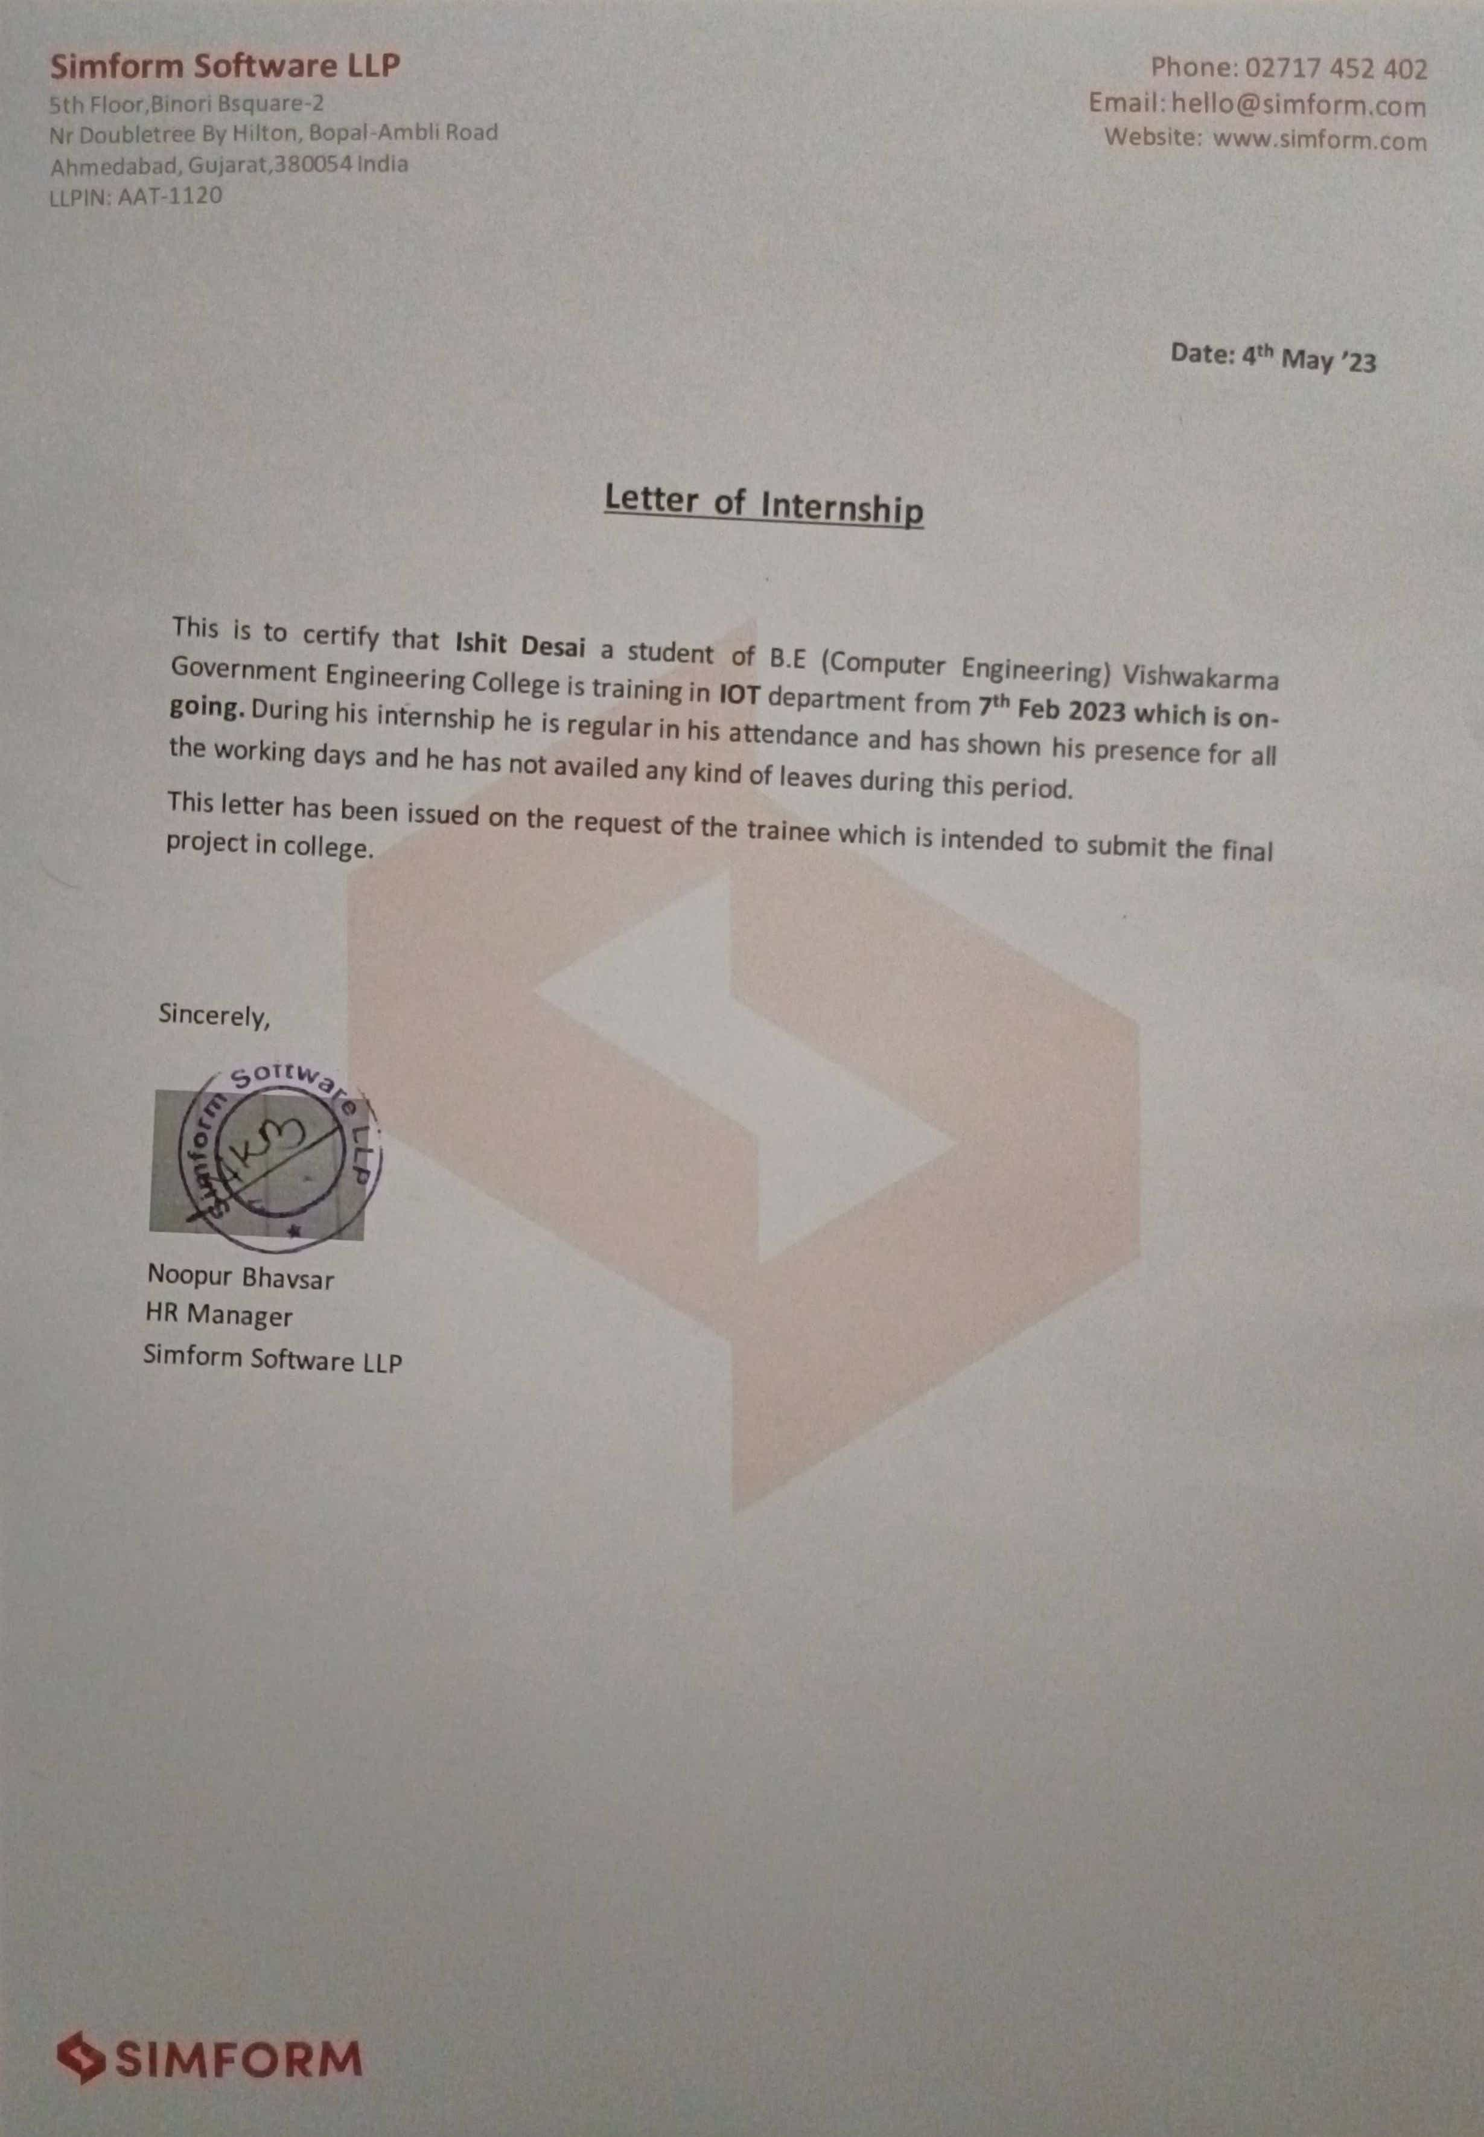

 

**VISHWAKARMA GOVERNMENT ENGINEERING COLLEGE**

Nr. Visat Three Roads, Sabarmati-Koba

Highway, Chandkheda, Ahmedabad,

Chandkheda - 382424

# **DECLARATION**

I hereby declare that the Internship report limitted along with the Internship entitled **SURVEILLANCE SYSTEM** submitted in partial fulfillment for the degree of Bachelor of Engineering in computer engineering to Gujarat Technological University, Ahmedabad, is a Bonafied record of original project work carried out by me at **Simform Solution** under the supervision of **Kamlesh Panchal** and that no part of this report has been directly copied from any students’ reports or taken from any other source, without providing due reference.

**Name of the Student** **Sign of Student**

Ishit Pragnesh Desai

(200170107501)

**Plagiarism Report**

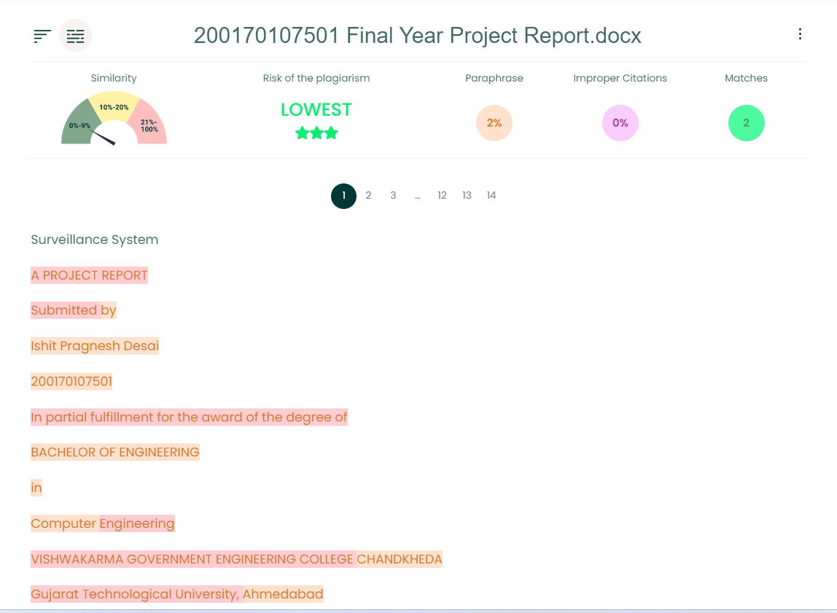

**ACKNOWLEDGEMENT**

The success and final outcomes of this internship required a lot of guidance and assistance from many people, and I am extremely privileged to have got this all through the completion of my internship. All that we have done is only due to such supervision and assistance and we should not forget to thank them.

I would like to take the opportunity to thank and express my deep sense of gratitude for my corporate mentor **Mr. Kamlesh Panchal**. I am greatly indebted to them for providing their valuable guidance at all stage of the study, their advice, constructive suggestions, positivity and supportive attitude and continuous encouragement, without it would have not been possible to complete the internship. I would also like to thank **Miss. Yesha Patel** Who in spite of busy schedule has co-operated with us continuously and indeed, her valuable contribution and guidance have been certainly indispensable for my internship work.

I heartily thank my faculty mentor of Computer Engineering department **Prof. Uttam Chauhan**. I am thankful to and fortunate enough to get constant encouragement, support and guidance from all teaching staffs of Information Technology which helped us in successfully completing my internship program. I am thankful to **Simform Solution** for giving me the opportunity. I owe my wholehearted thanks and appreciation to the entire staff of the company for their cooperation and assistance during the course of my work.

With sincere regards,

**Ishit Pragnesh Desai**

# **ABSTRACT**

# The proposed project aims to develop a surveillance system for military purposes that uses Arduino, ESP32CAM, NodeMCU, OpenCV, and YOLO detection to detect human intrusion. The system will consist of a camera module and a microcontroller that will capture and process images in real-time. The images will be analyzed using the OpenCV library and YOLO detection algorithm to detect human intrusion in the area. The system will use the ESP32CAM module to communicate with the internet, enabling real-time monitoring of the situation.

# The project aims to provide a cost-effective and efficient solution for surveillance in military operations. The system will be able to detect human intrusion with high accuracy, minimizing the chances of false alarms. Additionally, the system's open-source nature will enable easy customization and integration with other systems, providing maximum flexibility to military operations. Overall, the project's success will enhance the safety and security of military operations, contributing to the protection of soldiers and civilians alike.

**List of Figures**

Figure 1 Company Logo 13

Figure 2 AWS Partnership 14

Figure 3 Vonage Partnership 14

Figure 4 ButterCMS Certified 15

Figure 5 Organization Chart 17

Figure 6 Product Development Sequence 24

Figure 7 Circuit Diagram 40

Figure 8 Block Diagram 40

Figure 9 Flowchart 41

Figure 10 Surveillance Robot 46

Figure 11 FLASK GUI 46

**Abbreviations**

* **AWS**  – Amazon Web Services
* **API** – Application Programming Interface
* **AI** – Artificial Intelligence
* **UI** – User Interface
* **UX** – User Experience
* **SaaS** – Software as a Service
* **BI** – Business Intelligence
* **IoT** – Internet of Things
* **IDE** – Integrated Development Environment
* **OpenCV** – Open Source Computer Vision
* **YOLO** – You Only Look Once
* **CCTV** – Closed Circuit Television

### **Table of Contents**

Acknowledgement ..................................................................................................................i

Abstract .................................................................................................................................ii

List of Figures ......................................................................................................................iii

Table of Contents .................................................................................................................iv

**Chapter 1 Overview of the Company...............................................................................10**

* 1. History…….……………............................................................................................10
  2. Different Product........................................................................................................13
  3. Organization Chart......................................................................................................14

1.4 Capacity of Company..................................................................................................18

**Chapter 2 Overview of different department..................................................................19**

* 1. Details about the work being carried out in each department.………………………19
  2. List of tools and technologies used in each department…………………………….20

2.3 Schematic layout about sequence of operations for development of end product......21

2.4 Details of each stage....................................................................................................22

**Chapter 3 Introduction to Internship and Project .........................................................23**

* 1. Internship Summary……............................................................................................23
  2. Purpose…………........................................................................................................23
  3. Objective………….....................................................................................................23
  4. Scope…..………….....................................................................................................23
  5. Technology and Literature Review………………………………………………….25
  6. Project Planning……………………………………………………………………..26

3.7 Internship Scheduling……………………………………………………………….28

**Chapter 4 System Analysis……………………................................................................29**

* 1. Study of current system..............................................................................................29
  2. Problem and Weakness of current system…..............................................................30
  3. Requirements of New System...……..........................................................................31
  4. System Feasibility…………………………………………………………………...32
  5. Proposed System…………………………………………………………………….33
  6. Features of New System…………………………………………………………….34
  7. Processes…………………………………………………………………………….34
  8. Selection of Software and Hardware………………………………………………..35

**Chapter 5 System Design & Methodology………….......................................................36**

5.1 System Design….………...........................................................................................36

5.2 Circuit Design……………………………………………………………………….37

5.3 Input Output and interface design…………………………………………………...37

**Chapter 6 Implementation..……………………...............................................................39**

* 1. Implementation Platform…………….........................................................................39
  2. Process………….........................................................................................................39

6.3 Finding…………........................................................................................................40

**Chapter 7 Testing………………………………...............................................................41**

* 1. Testing Plan ………….…...........................................................................................41
  2. Testing results and analysis........................................................................................42

**Chapter 8 Conclusion and Discussion…………………………………………………..44**

8.1 Overall Analysis of Internship....................................................................................44

8.2 Dates of Continuous Evaluation ……………………………………………………44

8.3 Summary of Internship……………………………………………………………...44

**References ...........................................................................................................................45**

**CHAPTER 1: OVERVIEW OF THE COMPANY**

I got an internship at the Simform Solutions. Simform Solutions was founded in 2010 and works in several fields of data analysis, DevOps, cloud-native development, and quality engineering services. Simform Solutions offers software development, product integrations, cloud operations, and managed services to global enterprises and innovative start-ups.



Figure 1 Company Logo

### **1.1 HISTORY**

Simform Solutions was founded in 2010 by current CEO Prayaag Kasundra and current CTO Hiren Dhaduk with a vision to provide quality service in data engineering, product engineering and quality engineering. Going forward it expanded its horizon with product engineering, cloud and devops engineering, data engineering, and quality engineering. Simform Solutions was started with 1 person organization and now it operates with over 1000 employees in it.

1. Location and spread of the company: We have offices in 12 different locations in global i.e., India, USA, Canada

2. Number of employees: 1000+

**1.1.2 PLATFORM AND TECHNOLOGY PARTNER**

1. **AWS Advanced Consulting Partner**

With AWS, Simform assists you with **cloud deployment**, cloud to cloud integration services, CloudOps, networking, data engineering among a host of other cloud-based services.

Our **AWS certified developers**, architecture associates, and cloud consultants are the best you can get to harness most of AWS offerings. Whether it’s migrating legacy systems, extending existing cloud capabilities, or executing a new cloud-based service, we’ve got you covered. We leverage our experience of successfully deploying 500+ cloud projects across 14 industries to address your cloud-related requirements.



Figure 2 AWS Partnership

1. **Vonage API Integration Partner**

We empower our customers with dynamic solutions that allow them to deliver **unique customer experiences** and nurture customer engagement.

We work as Vonage’s, previously known as Nexmo, API integration partner to facilitate the integration of programmable communication such as video, voice, text, SMS, and social, to apps, databases, and systems. Our alliance has helped start-ups and enterprises dramatically increase their impact on healthcare, Edutech, virtual events, social platforms among others.



Figure 3 Vonage Partnership

1. **Microsoft Gold Partner**

With the shared vision of **accelerating enterprise innovations**, Microsoft Gold Partnership and Simform offer high-quality products that power your business.

To ensure you get the most out of our 50+ Microsoft consultants and cloud solution architects, we put together a dedicated team of developers that best suit your profile. Be it the use of Power BI to facilitate your decision-making capacity, SQL Server and Azure SQL to help with data management, and Microsoft .NET for improved reliability, Simform is equipped with the expertise your business needs.

1. **ButterCMS Certified Partner**

ButterCMS, an API-driven headless CMS, and Simform are transforming the way how **content is delivered and managed** across digital platforms.

Our partnership allows organizations from startups to enterprises to build scalable products using [**ButterCMS**](https://buttercms.com/) for a variety of use cases such as e-commerce, SaaS, marketplaces, and multisite. With ButterCMS’s flexibility and scalability & Simform’s product engineering skills, you’re equipped with the technical prowess required to build content-driven products that are easy to scale.



Figure 4 ButterCMS Certified

**1.2 DIFFERENT PRODUCTS / SCOPE OF WORK**

Simform is a **digital product engineering and IT talent solutions company** with a mission to solve complex software engineering problems.

**1.2.1 Customer Data Management**

It helps in building a holistic view for the customers. Truly connected customer experiences across every channel and touchpoint give you a competitive edge in the marketplace. That’s why it fuses experience-forward mindset with deep expertise in data and technology platforms that builds seamless customer journeys for the clients. The process starts by implementing a rock-solid customer 360 data management strategy. This informs where and how your customer data is consolidated to drive contextual personalization on a 1:1 level. Next, our team leverages an enterprise-grade customer data platform (CDP) to unify your data and connect it to other systems sparking the creation of personalized customer journeys. Throughout the process, our expertise empowers us to gather the right data and keep it clean, protected, consistent, and actionable.

**1.2.2 Digital Experience Management**

It helps in specializing in strategizing, creating and executing enterprise experience management platform (EXM) solutions that elevate customer experiences while driving business outcomes. But where we truly excel is maximizing the potential of EXM platforms to create seamless engagements that span devices, consumer/personal segments, regions/countries/languages and more.

**1.2.3 Analytics & AI**

The promise of delivering real-time experiences is no longer science fiction. By harnessing oceans of customer data, machine learning and AI platforms are answering customer needs today while also anticipating what they want tomorrow. But data itself is not a solution. Collecting it is so deceptively simple that many companies often drown themselves in data points rather than using them to drive actions that prove real value. We partner with clients to proactively collect data and act on it in real-time all to power in-the-moment interactions with your customers and optimize future experiences with your organization. In addition, we leverage best-of-breed machine learning and AI technologies to take these insights further by accurately predicting customer behaviors and personalizing experiences that build both long-term relationships and greater possibilities in the process.

**1.2.4 Managed Services**

Users expect digital experiences that are safe, always-on and lightning fast. Downtime, lag time, missing data and bugs can cost businesses dollars and customers. We specialize in proven enterprise class infrastructure and integration solutions to connect systems and data in ways that are seamless and secure and blazing fast. We pride ourselves on providing safe hands and a knowledgeable team to guide customers through hosting, connecting, securing, scaling and governing their experience platform infrastructure.

**1.3 ORGANIZATION CHART**

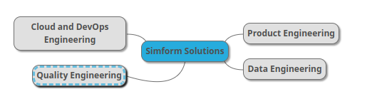

Figure 5 Organization Chart

## **1.3.1.** **Digital product development services**

#### **1.3.1.1. Product Discovery & Design Services**

Replace guesswork with **product discovery** and proven processes. We create a strategic canvas and work with you to understand user flows and jobs to be done.

#### **1.3.1.2**. **UX Design & UI Development Services**

Use data to understand what customers do and why they do it. **Intuitive user flows** are created that make users jobs easier. Our creative developers build interactions to bring the vision to life.

#### **1.3.1.3.** **Rapid Prototype Building Services**

We are obsessed with getting it right. We **build prototypes** from research insights and bring users into the process early to validate, iterate, and optimize towards your vision.

#### **1.3.1.4. Apps Development Services**

Bringing product designs to life is a challenge for many companies. We have a track record of **architecting for scale** and building products through the iterative development process.

#### **1.3.1.5. Product Transformation & Re-engineering**

Upgrade your product to richer UX or new architecture enabling SaaS delivery. We offer **hassle-free product transformation** services ensuring minimal impact on existing users.

#### **1.3.1.6 Usability Testing Services**

Learn more about your existing product or your competitions with **usability testing.** Our team of expert researchers will help you plan, manage, and moderate tests.

**1.3.2 Cloud and DevOps Engineering**

### **1.3.2.1 Cloud-native App Development**

Fast forward your business outcomes by leveraging Simform’s cloud native app development services. Our robust cloud engineering proficiency and variety of services helps your organization make the most of the cloud in all its forms.

### **1.3.2.2 Cloud Consulting**

Utilize our best-in-class cloud consulting services to give your business a competitive edge with expert cloud consultants. As a result, we help your business reduce extra costs, scale faster and increase the scalability of solutions.

### **1.3.2.3 Microservices Architecture**

Our end-to-end microservices architecture and deployment services help you remodel your application into independent and scalable microservices that allows you to offer a seamless user experience. Leverage the power of on-demand scalability.

### **1.3.2.4 Data and Analytics Consulting**

Unlock the potential of data with our range of data analytics services. Drive critical business insights that help you supercharge your organization's agenda. We help you model and collect user data that strengthens your decision-making process.

### **1.3.2.5 Serverless**

Enjoy the automatic scalability and reduced operational costs with our serverless application development and consulting services. Forget about the backend provisioning or maintenance and focus solely on delivering an exceptional user experience to your customers.

### **1.3.2.6 Kubernetes Consulting**

Elevate your application’s performance by leveraging the best-in-class Kubernetes consulting services. We help you harness the power of Kubernetes' features like deployment patterns, canary deployment, failover monitoring system, etc.

### **1.3.2.7 Cloud Migration Consulting**

Simform’s cloud migration services include evaluating the existing infrastructure and providing organizations the tools and methodologies required to migrate their complex and business-critical applications to the desired cloud infrastructure and architecture.

### **1.3.2.8 Cloud Architecture design and review**

Leverage cloud capabilities like automation and orchestration with a resilient cloud platform to innovate safely, implement the latest cloud capabilities, and minimize system downtime with proven cloud architecture design services and tested strategies.

### **1.3.2.9 Cloud Assessment**

Optimize the ROI of your cloud infrastructure with Simform. Our world-class cloud assessment and cost optimization services are designed to help organizations make the most of their cloud infrastructure.

**1.3.3 Data Engineering**

Our Data and BI experts help you bridge the gap between your data sources and your business goals so everyone on your team can analyze and examine your data from a variety of perspectives, gather new and meaningful insights, draw robust reports, and make actionable business decisions.

### **1.3.3.1 Data analytics**

Our team helps you map your data analytics strategy to ensure you derive quantifiable business outcomes using a data-driven approach.

Moreover, we help you establish solid practices that set the stage for growth.

### **1.3.3.2 Data lakes and Data warehouses**

Our team assists you create a scalable platform with the ability to ingest data from multiple sources.

Platforms to store, process, and secure large amounts of structured, semi structured, and unstructured data irrespective of the size.

### **1.3.3.3 Data consulting and advisory**

Thriving with your data starts with a solid strategy.

Our data and analytics consultants help you develop a long-term, guiding plan that defines the people, processes, and technology you need to put in place so you can start using your data to achieve your business goals.

### **1.3.3.4 Power BI quick start**

Leverage the best of Power BI and Simform to create, share, and consume business insights in the way that serves you and your business most effectively.

Bring your data to life using easy-to-use dashboards, interactive reports, and compelling visualizations.

**1.3.4 Quality Engineering**

We offer software testing services focused on delivering quality products. Our testing best practices like "test early, test often" and "proactive planning of software test cycles" have made us come a long way in serving your software testing needs. Our highly skilled quality assurance engineers are experienced in testing end-to-end workflows and executing test case scenarios. In addition, our dedicated teams ensure independent testing for your applications based on smart techniques and the latest technology.  
  
We employ world-class software testing practices and improve overall time-to-market and quality. We aim to provide higher test coverage and accurate deliverables. What differentiates us from others is that we create testing guidelines for organizations that aim at cost efficiency, optimized use of QA resources, and reduced risk of failure. Hence, we provide guaranteed customer satisfaction rather than just focusing on delivering tested products.

* + Optimized resource utilization
  + Faster time-to-market
  + Aligned with business needs
  + Mitigated technical risks
  + Consistent agile-driven software testing approach
  + Cost-effective testing techniques
  + Better test coverage and ROI analysis

### **1.4 CAPACITY OF COMPANY**

Currently our company holds over 1000 employees. But as the company is growing rapidly its capacity is getting higher and higher.

## **CHAPTER 2: DIFFERENT UNITS OF AN** **ORGANIZATION**

As the company has grown, it was needed to separate various departments to maintain the management and smooth flow of process. Simform Solutions has various units to handle different use cases.

**2.1. DETAILS ABOUT THE WORK BEING CARRIED OUT IN EACH DEPARTMENT**

**1. UI/UX Department:**

After getting the requirements from the client flow starts form this department, this department handles clients’ requirements very carefully and implements client’s ideas into design.

**2. Front End Department:**

A front-end department is responsible for implementing visual elements that users see and interact with in a web application. They are usually supported by back-end web developers.

**3. Back End Department:**

A back-end web developer is responsible for server-side web application logic and integration of the work front-end web developers do. Back-end developers usually write web services and APIs used by front-end developers and mobile application developers. Integration of user-facing elements developed by a front-end developer with server-side logic Implementation of security and data protection Design and implementation of data storage solutions building reusable code and libraries for future use

**4. QA Department:**

The main goal of the Quality Assurance (QA) department is to help create a quality product. Their job is not only bug searching and regular product testing, but to also prevent defects accordingly. They ensure the high quality of the development process and its results. Testing the product during all phases of the software development lifecycle (SDLC) Identifying weaknesses and inconsistencies in the product helping to identify project requirements providing the team with complete information on product quality

**5. HR Department:**

An HR department is tasked with maximizing employee productivity and protecting the company from any issues that may arise within the workforce. HR responsibilities include compensation and benefits, recruitment, firing, and keeping up to date with any laws that may affect the company and its employees managing and using people effectively tying performance appraisal and compensation to competencies Increasing the innovation, creativity, and flexibility necessary to enhance competitiveness managing the implementation and integration of technology through improved staffing, training, and communication with employees.

**6. IOT Department:**

The department is responsible for a range of activities, including research and development, designing and prototyping IoT solutions, testing and validation, deployment, and ongoing maintenance and support. The department works in close collaboration with other departments such as IT, engineering, and marketing, to ensure that the IoT solutions developed align with the company's overall strategy and objectives.

**2.2. LIST OF MAJOR TOOLS AND TECHNOLOGIES USED IN EACH DEPARTMENT**

**1. Front End Department:**

Technologies: HTML, CSS, SCSS, jQuery, React, NodeJS

Tools: Microsoft Visual Studio Code, Photoshop, Invision

**2. Back End Department:**

Technologies: Sitecore 10, .NET MVC, Microsoft SQL Server 2019 Tools: Microsoft Visual Studio, SQL Server Management Studio

**3. QA Department:**

Qmetry, SnagIt, Sitecore, Java Programming, Selenium IDE and

WebDriver

**4. HR Department:**

GreytHR

**2.3. SCHEMATIC LAYOUT ABOUT SEQUENCE OF OPRATIONS FOR DEVELOPMENT OF END PRODUCT**

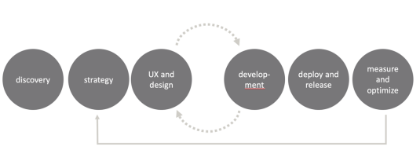

Figure 6 Product Development Sequence

Above Chart/Figure Show how the work is carried out in organization and in figure as we can see the flow the very first step will be the discovery after that planning/strategy phase and then design and development phase there might me some back-and-forth situation between design and development because of requirements changes after that deployment and final stage will be measurement and optimization that will repeat whole cycle if there is any optimization.

**2.4. DETAILS OF EACH STAGE:**

**a. Discovery:**

Discovery is the first phase of the service design and delivery process. Doing user research during Discovery is critical to understand the problem you need to solve for your users. When you know their challenges, needs and wants, you gain insights into what aspects of the problem you will need to prioritise. Discovery usually takes between four to eight weeks.

**b. Strategy:**

Planning and testing a project must be directly linked to its strategy. In this phase, you put the project under the microscope and analyse all the details. It involves making strategic decisions on who will be assigned what duties in the project, designing a timetable, and setting timescales, allocating resources, and putting in place measures that will ensure that forecasts made in the initiation stages are met. Mapping out the project in well-articulated details gives the project bigger chances of success.

**c. UX and Design:**

Project design is an early phase of the project where a project's key features, structure, criteria for success, and major deliverables are all planned out. The aim is to develop one or more designs that can be used to achieve the desired project goals.

**d. Development:**

Development stage refers to the first phase in the life cycle of a new business. During the development stage, companies focus on establishing themselves through activities such as market research, product development, and the construction of new manufacturing facilities.

**e. Deploy and Release:**

Release and Deployment aims to plan, schedule, and control the movement of releases to test and live environments. The primary goal of this process is to ensure.

**CHAPTER 3: INTRODUCTION TO INTERNSHIP AND PROJECT**

**3.1 INTERNSHIP / PROJECT SUMMARY**

I have joined Simform as IoT Trainee Engineer and currently working as an Intern. Goal of this internship/training is to get grip on fundamental technology for respective department and understanding how we approach it at here Simform. And for that we have worked on an internal project that is in level of real-time industry project.

# **Project Title: Surveillance System**

Continuous learning is the core of self-growth. It is also a return on an investment done on you by the organization. To provide a shared and guided platform which has the trainings that can be in textual format, internal or external recordings. Team members can register themselves and then look for the designated trainings based on the categories tagged for these individual trainings, once they login. They would also have a provision to add their feedback, comments, their learnings etc. for these individual trainings. There would be a Certification section as well which will have official certifications linked to the trainings. A dashboard would have a provision to publish the achievements and certifications displayed.

**3.2 PURPOSE**

Learning and implementing the core technologies for respective departments. Learning and following standards and best practices while developing Getting Ready for Live Clients Projects. Learning to work in collaborative way with other departments. Understanding Agile Methodologs. Hands on practice and training of latest technologies.

**3.3 Objective**

Provide a training platform to the Simform’s team members for team and self-upgrade.

**3.4 Scope**

The proposed project aims to develop a surveillance system for military purposes that uses Arduino, ESP32CAM, OpenCV, and YOLO detection to detect human intrusion. The system has the potential to provide real-time monitoring of an area, detect human intrusion with high accuracy, and minimize the chances of false alarms.

The system can detect human intrusion in the area, but it is important to note that it cannot differentiate between hostile and non-hostile intruders. It is the responsibility of the military personnel to evaluate the situation and determine the appropriate response.

The surveillance system can operate in different weather conditions, but extreme weather conditions such as heavy rain or snow may affect the camera's performance. The system can be customized and integrated with other systems to enhance its capabilities, but it is important to ensure that the system complies with relevant regulations and standards and is secure and reliable.

Overall, the surveillance system has the potential to enhance the safety and security of military operations by providing real-time monitoring of the situation and detecting human intrusion with high accuracy. However, it is important to note that the system is not a substitute for human intervention and evaluation. The system can provide valuable information and support to military personnel, but it is ultimately up to them to make the final decision based on the situation at hand.

**3.4.1 Applications in Military**

**1**. **Border Protection:** The system can be used to monitor borders and detect any unauthorized intrusion by detecting human presence with high accuracy.

**2.** **Base Security:** The system can be used to secure military bases by detecting any suspicious human activity within and around the base premises.

**3.** **Tactical Operations:** The system can be used in tactical operations to monitor the area of operations and detect any human presence, giving military personnel valuable information about the situation.

**4.** **Force Protection:** The system can be used to protect military personnel by detecting any human presence that may pose a threat to their safety.

Overall, the proposed surveillance system has several applications in the military, where real-time monitoring and accurate detection of human intrusion can significantly enhance the safety and security of military operations. The system can provide valuable support to military personnel and enable them to make informed decisions based on the situation at hand.

**3.5 Technology and Literature Review**

**3.5.1 Technology Review:**

The proposed surveillance system uses several technologies to detect human intrusion accurately. These technologies include:

1. **Arduino:** Arduino is an open-source microcontroller board that provides a platform for developing and prototyping electronic projects. In this project, Arduino is used to control and interface with the ESP32CAM.
2. **ESP32CAM:** ESP32CAM is a low-cost, compact module that integrates a camera and Wi-Fi capabilities, making it suitable for IoT applications.
3. **OpenCV:** OpenCV is an open-source computer vision library that provides a range of algorithms for image and video analysis, including object detection and tracking.
4. **YOLO Detection:** YOLO (You Only Look Once) is a real-time object detection algorithm that uses deep learning to detect objects in images and videos.

**3.5.2 Literature Review:**

Several research studies have been conducted on the use of IoT technologies for surveillance purposes. Some relevant studies include:

1. "Intelligent Surveillance Robot with Obstacle Avoidance Capabilities Using Neural Network " by Pietro Arico. This study proposes vision-based surveillance robot that can be run autonomously and able to acquire images from its dynamic environment is very important. [[1]](https://www.hindawi.com/journals/cin/2015/745823/)
2. "Security Surveillance Robot" by SMP Robotics Systems Corp. [[2]](https://smprobotics.com/security_robot/security-surveillance-robot/)
3. "Design and Implementation Surveillance Robot Using ATmega328 Microcontroller" by Anas F Ahmed. [[3]](https://www.researchgate.net/publication/329894828_Design_and_Implementation_Surveillance_Robot_Using_ATmega328_Microcontroller)

Overall, the literature review suggests that IoT technologies, combined with computer vision and machine learning algorithms, have the potential to enhance the capabilities of surveillance systems. The proposed project builds upon these existing studies and utilizes a combination of Arduino, ESP32CAM, OpenCV, and YOLO detection to develop a surveillance system for military purposes.

**3.6 PROJECT PLANNING**

**3.6.1 Project Development Approach and Justification**

**Development Approach:**

For the development of the proposed surveillance system, an agile development approach will be used. The agile development approach is well-suited for projects that require flexibility and adaptability to changing requirements. The approach involves dividing the project into small, iterative cycles or sprints, with each sprint delivering a working increment of the software. The agile approach encourages to adapt to changes quickly.

**Justification:**

The proposed surveillance system project requires a flexible and adaptable development approach due to the complex and evolving nature of the project. The use of an agile development approach allows the development team to respond quickly to changes in requirements, integrate feedback from stakeholders, and deliver working increments of the system at regular intervals. Additionally, the agile approach fosters collaboration, communication, and transparency, ensuring that the final system meets the project requirements and is delivered on time.

**3.6.2 Project Effort and Time, Cost Estimation**

The project timeline for the proposed surveillance system project is as follows:

1. **Project initiation (Week 1)**
   * Define project objectives and scope
   * Identify project requirements
   * Develop project plan
2. **Hardware setup and testing (Week 2-3)**
   * Procure hardware components
   * Set up hardware and software environment
   * Test hardware components
3. **Software development (Week 4-5)**
   * Develop software components using OpenCV and YOLO detection
   * Integrate software components with hardware components
   * Test software components
4. **System integration and testing (Week 6-7)**
   * Integrate software and hardware components
   * Perform functional testing of the system
   * Identify and fix defects
5. **System optimization (Week 8-9)**
   * Optimize the system performance
   * Perform load testing
   * Identify and fix performance issues
6. **Documentation and training (Week 10-11)**
   * Develop system documentation
   * Develop training materials
7. **Project closure (Week 12)**
   * Perform final testing and validation
   * Obtain mentor acceptance

**3.6.3 Roles and Responsibilities**

**Role:** Associate Software Engineer Intern

**Responsibilities:**

1. Focus on Learning
2. Understanding Requirements
3. Performed Practical's
4. Daily update status
5. Explore concepts in depth

**3.6.4 Group Dependencies**

Dependencies are the relationships between work that determine the order in which the work items (features, stories, tasks) must be completed by Agile teams.

No project is managed in a vacuum. Within a single project, dependencies occur – between people, steps, functions, or teams.

**3.7 Internship Scheduling**

Scheduling in project management is the listing of activities, deliverables, and milestones within a project. A schedule also usually includes a planned start and finish date, duration, and resources assigned to each activity. Effective project scheduling is a critical component of successful time management.

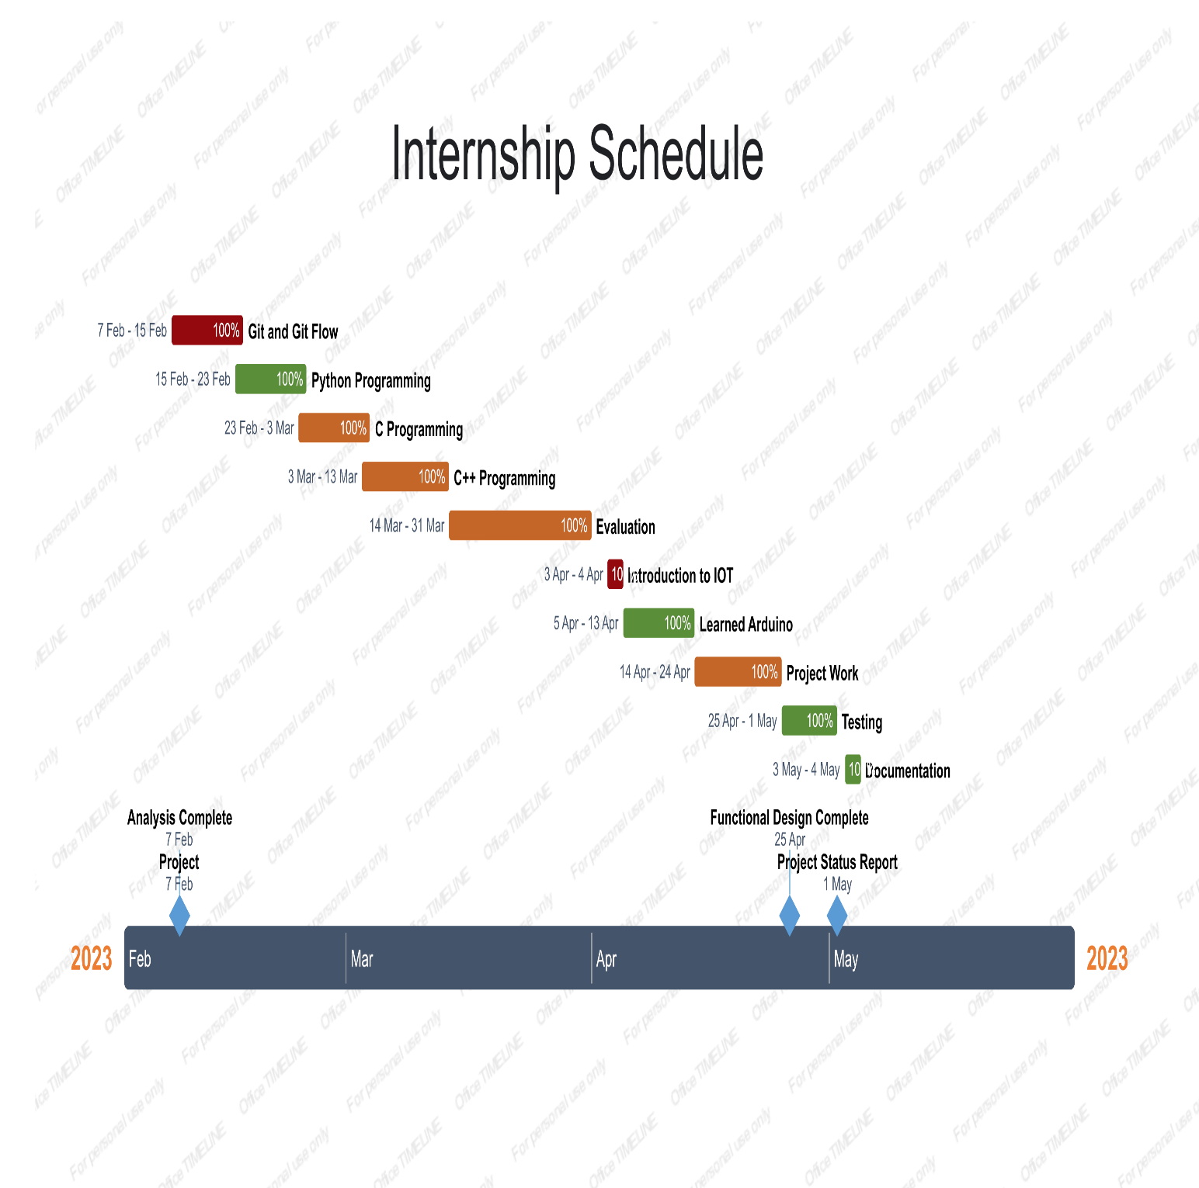

**CHAPTER 4: SYSTEM ANALYSIS**

**4.1 Study of Current System**

Some of the current surveillance systems available in the market include:

1. **Closed-Circuit Television (CCTV) System:** A CCTV system is a video surveillance system that uses cameras to capture and record video footage of a specific area. The system is commonly used in military settings for monitoring and recording activities in the area. However, the system is limited in detecting human intrusion and requires human monitoring and analysis to detect any suspicious activity.
2. **Motion Detection System:** A motion detection system uses sensors to detect motion in a specific area. The system can be integrated with an alarm or alert system to notify the user of any motion detected. However, the system can be triggered by non-human motion, such as animals, and may result in false alarms.
3. **Infrared Detection System:** An infrared detection system uses infrared sensors to detect the presence of a human in a specific area. The system can be integrated with an alarm or alert system to notify the user of any human presence detected. However, the system is limited in detecting the movement of the intruder and may result in false alarms due to animals or environmental factors.
4. **Acoustic Detection System:** An acoustic detection system uses sound sensors to detect and analyze the sound waves in a specific area. The system can be integrated with an alarm or alert system to notify the user of any suspicious sounds detected. However, the system is limited in detecting the source of the sound and may result in false alarms due to environmental factors such as wind or rain.

**4.2 Problem and Weaknesses of Current System**

1. **False alarms:** Many current systems are triggered by non-human motion or environmental factors, resulting in false alarms that can waste valuable time and resources for military personnel.
2. **Limited detection capabilities:** Some systems can only detect the presence of humans, but not their movements or activities. This makes it difficult to determine if the intrusion is a threat or not.
3. **Human monitoring:** Some systems rely on human monitoring and analysis to detect suspicious activity, which can be time-consuming, expensive, and prone to errors.
4. **Limited range:** Some systems have limited range or coverage, making it difficult to monitor large areas or long perimeters.
5. **Vulnerability to hacking:** Some systems are vulnerable to hacking, which can compromise the security of military facilities and operations.
6. **Inability to integrate with other systems:** Some systems are not compatible with other security systems, making it difficult to coordinate and respond to security threats.
7. **Lack of real-time monitoring and response:** Some systems do not provide real-time monitoring and response, which can delay the detection and response to security threats.

**4.3 Requirements of New System**

The proposed surveillance system has several requirements that must be met to ensure its effectiveness in detecting human intrusion in military settings. Some of these requirements include:

1. **High accuracy:** The system must have a high level of accuracy in detecting human presence and activities to minimize false alarms and ensure timely and effective responses to security threats.
2. **Real-time monitoring and alerts:** The system must provide real-time monitoring and alerts to enable rapid responses to security threats.
3. **Integration with other security systems:** The system must be compatible with other security systems and able to integrate with them to provide a comprehensive and coordinated approach to security.
4. **Wide coverage:** The system must have wide coverage to monitor large areas and long perimeters effectively.
5. **Durability:** The system must be durable and able to withstand harsh weather conditions and potential physical damage.
6. **Easy installation and maintenance:** The system must be easy to install and maintain to minimize downtime and reduce the need for extensive technical expertise.
7. **Scalability:** The system must be scalable to accommodate future expansion and upgrades.
8. **Security:** The system must be secure and resistant to hacking to ensure the confidentiality, integrity, and availability of data.

Meeting these requirements will ensure that the proposed surveillance system is effective, efficient, and reliable in detecting and alerting human intrusion in military settings.

**4.4 System Feasibility**

**4.4.1 The System Contribute to the overall objectives of the organization**

The contribution of a surveillance system to the overall objectives of an organization will depend on the nature of the organization and the specific application of the surveillance system. Here is the examples of how a surveillance system may contribute to the objectives of military organizations:

1. Military: A surveillance system can contribute to the objectives of a military organization by providing early warning of incoming threats, enabling rapid response and defence.

**4.4.2 Can the system be implemented with current technologies and be completed within the given effort and time.**

The proposed surveillance system can be implemented with current technologies and completed within the given effort and time with proper planning and execution.

Arduino and ESP32CAM are widely used microcontroller and camera modules, and OpenCV and YOLO are popular computer vision libraries that have been extensively tested and validated in various applications. The integration of these technologies to create a surveillance system is feasible and can be achieved within a reasonable time frame.

However, the implementation of such a system requires a significant amount of time and effort in the design, development, and testing phases. The design phase includes identifying and analyzing the requirements, selecting the appropriate hardware and software components, and designing the system architecture. The development phase involves coding, integrating the components, and testing the system. The testing phase includes verifying the system's functionality, performance, and security and addressing any issues that arise.

The effort and time required for each phase depend on various factors, such as the complexity of the system, the expertise of the development team, and the availability of resources. Therefore, it is crucial to have a well-planned project schedule, a competent development team, and adequate resources to ensure the successful implementation of the proposed surveillance system.

**4.4.3 Can the system be integrated with other systems which are already in place?**

Yes, the proposed surveillance system can be integrated with other systems that are already in place.

The system's compatibility with other security systems is one of its requirements, which means it must be able to work seamlessly with other systems, such as access control, alarm monitoring, and security cameras, among others. To achieve this, the system must have open communication protocols that enable it to exchange data and commands with other s-ystems.

In addition, the integration process should follow established integration standards and protocols to ensure compatibility and avoid potential conflicts or data loss. The integration process should also consider the system's scalability to accommodate future expansion and upgrades of the surveillance system and other security systems.

Overall, the successful integration of the proposed surveillance system with other security systems requires careful planning, execution, and testing to ensure the interoperability, security, and functionality of the integrated systems.

**4.5 Proposed System**

The proposed surveillance system is designed to detect and alert human intrusion in military settings. The system comprises the following components:

1. **Arduino board:** The Arduino board is the central processing unit that controls the system's operation. It receives input from headquarter to control the device.
2. **ESP32CAM camera module:** The ESP32CAM camera module captures the video feed from the surveillance area and sends it to the Arduino board for processing. It features a built-in Wi-Fi module that enables remote monitoring and control of the system.
3. **OpenCV computer vision library:** OpenCV is a powerful computer vision library that provides the image processing algorithms required to detect human intrusion in the surveillance area. It is used to analyze the video data from the ESP32CAM camera module and identify human presence and activities in real-time.
4. **YOLO detection algorithm:** The YOLO (You Only Look Once) detection algorithm is used to identify and classify human objects in the video feed. It is optimized for real-time performance and accuracy and can handle multiple objects simultaneously.
5. **Alert system:** The alert system triggers an alarm or notification when human intrusion is detected in the surveillance area. It can be configured to send alerts to a central monitoring station, a mobile device, or an email address.

The proposed surveillance system can be installed at strategic locations around military bases and installations to monitor and detect human intrusion in real-time. It provides a cost-effective and reliable alternative to human security personnel, reducing the risk of human error and improving overall security and safety. The system can also be integrated with other security systems to provide a comprehensive and coordinated approach to security.

**4.6 Features of New System**

The proposed surveillance system has several features that make it suitable for military applications:

1. **Real-time monitoring:** The system provides real-time monitoring of the surveillance area, allowing for immediate detection and response to human intrusion.
2. **Accurate detection:** The YOLO detection algorithm used in the system is optimized for accuracy and can detect and classify multiple human objects simultaneously.
3. **Cost-effective:** The system is cost-effective compared to traditional security measures.
4. **Remote monitoring and control:** The ESP32CAM camera module features a built-in Wi-Fi module that enables remote monitoring and control of the system from a central location.
5. **Customizable alert system:** The alert system can be customized to trigger alarms or notifications based on user-defined criteria, such as the number of humans detected, their location, or their behavior.
6. **Scalable:** The system is scalable, allowing for easy expansion to cover larger areas or integrate with other security systems.
7. **Easy to install and maintain:** The system is easy to install and maintain, with minimal technical expertise required.

Overall, the proposed surveillance system provides a reliable and efficient way to monitor and detect human intrusion in military settings, improving security and safety while reducing costs and minimizing the risk of human error.

**4.7 Processes**

The proposed surveillance system follows the following processes:

1. **Video capture:** The ESP32CAM camera module captures the video feed from the surveillance area and sends it to server at headquarter.
2. **Video processing:** The video data is processed using the OpenCV computer vision library to identify human presence and activities in real-time.
3. **Object detection:** The YOLO detection algorithm is used to identify and classify human objects in the video feed.
4. **Alert triggering:** The system triggers an alert or notification when human intrusion is detected in the surveillance area. This can be configured to send alerts to a central monitoring station, a mobile device, or an email address.
5. **Alert response:** When an alert is triggered, appropriate measures are taken to respond to the intrusion, such as deploying security personnel or activating other security systems.
6. **System monitoring:** The system is continuously monitored for any errors or malfunctions, and appropriate measures are taken to address them promptly.
7. **System maintenance:** Regular maintenance activities are performed to ensure the system's optimal performance and longevity, such as software updates, hardware replacements, and system upgrades.

**4.8 Selection of Software and Hardware**

**4.8.1 Hardware**

1. **Arduino board:** Any Arduino board with sufficient processing power can be used, such as Arduino Uno, Arduino Mega, or Arduino Due.
2. **ESP32CAM camera module:** This module features a built-in Wi-Fi module and a 5-megapixel camera, making it ideal for real-time surveillance applications.
3. **NodeMCU:** This module features a built-in Wi-Fi module to communicate with headquarter central server.
4. **Power supply:** The system requires a stable power supply to ensure continuous operation. A 5V/2A power supply can be used to power the Arduino board, NodeMCU and the ESP32CAM module.

**4.8.2 Software**

1. Arduino Integrated Development Environment (IDE)
2. OpenCV library
3. YOLO object detection algorithm
4. Programming languages (C++, Python)

**CHAPTER 5: SYSTEM DESIGN**

**5.1 SYSTEM DESIGN & METHODOLOGY**

**5.1.1 System Design:**

1. The ESP32CAM camera module captures the video feed from the surveillance area and sends it to the server at headquarter.
2. The video data is processed using the OpenCV computer vision library to identify human presence and activities in real-time.
3. The YOLO detection algorithm is used to identify and classify human objects in the video feed.
4. When human intrusion is detected in the surveillance area, the system triggers an alert or notification. This can be configured to send alerts to a central monitoring station, a mobile device, or an email address.
5. When an alert is triggered, appropriate measures are taken to respond to the intrusion, such as deploying security personnel or activating other security systems.

**5.1.2 Methodology:**

1. **Requirement analysis:** The first step is to analyze the requirements of the surveillance system, including the surveillance area, the type of intrusion detection required, and the response mechanisms in place.
2. **Hardware selection:** Once the requirements are analyzed, the appropriate hardware components are selected based on the system's needs and constraints.
3. **Software development:** The system software is developed using the Arduino IDE, OpenCV library, YOLO detection algorithm, and programming languages such as C++ and Python.
4. **System integration:** The hardware and software components are integrated, and the system is tested to ensure that it meets the requirements and functions as intended.
5. **System testing:** The system is tested under different conditions, including varying lighting conditions, human activity levels, and environmental factors.

**5.2 CIRCUIT DESIGN / PROCESS DESIGN / STRUCTURE DESIGN**

**5.2.1 CIRCUIT DESIGN**

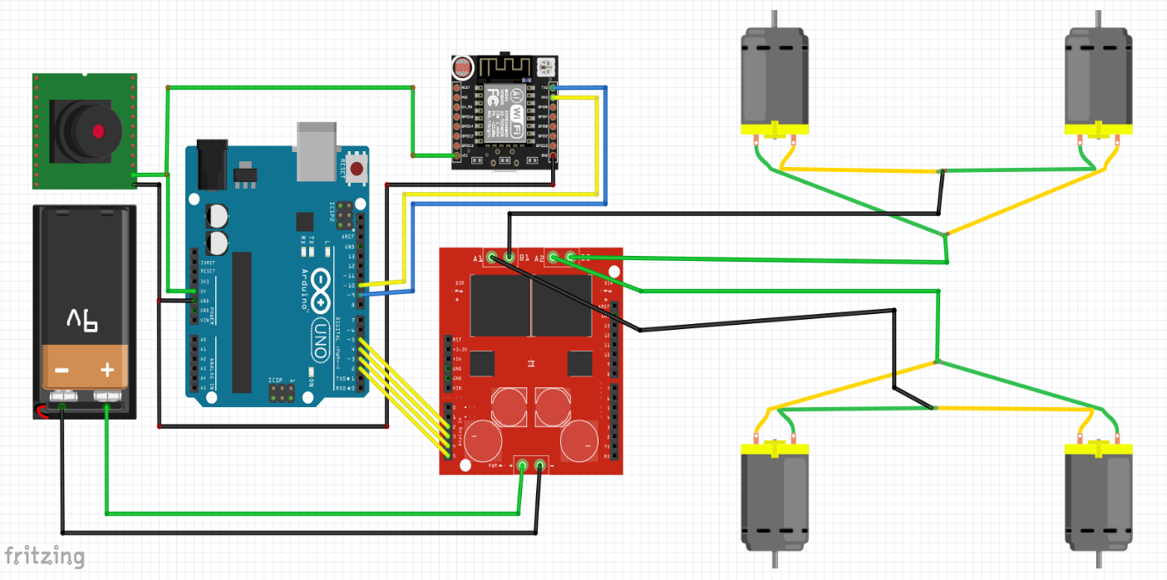

Figure 7 Circuit Diagram

**5.3 INPUT / OUTPUT AND INTERFACE DESIGN**

**5.3.1 Block Diagram**

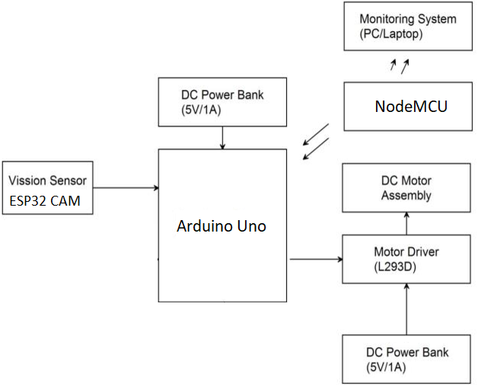

Figure 8 Block Diagram

**5.3.2 Flow Chart**

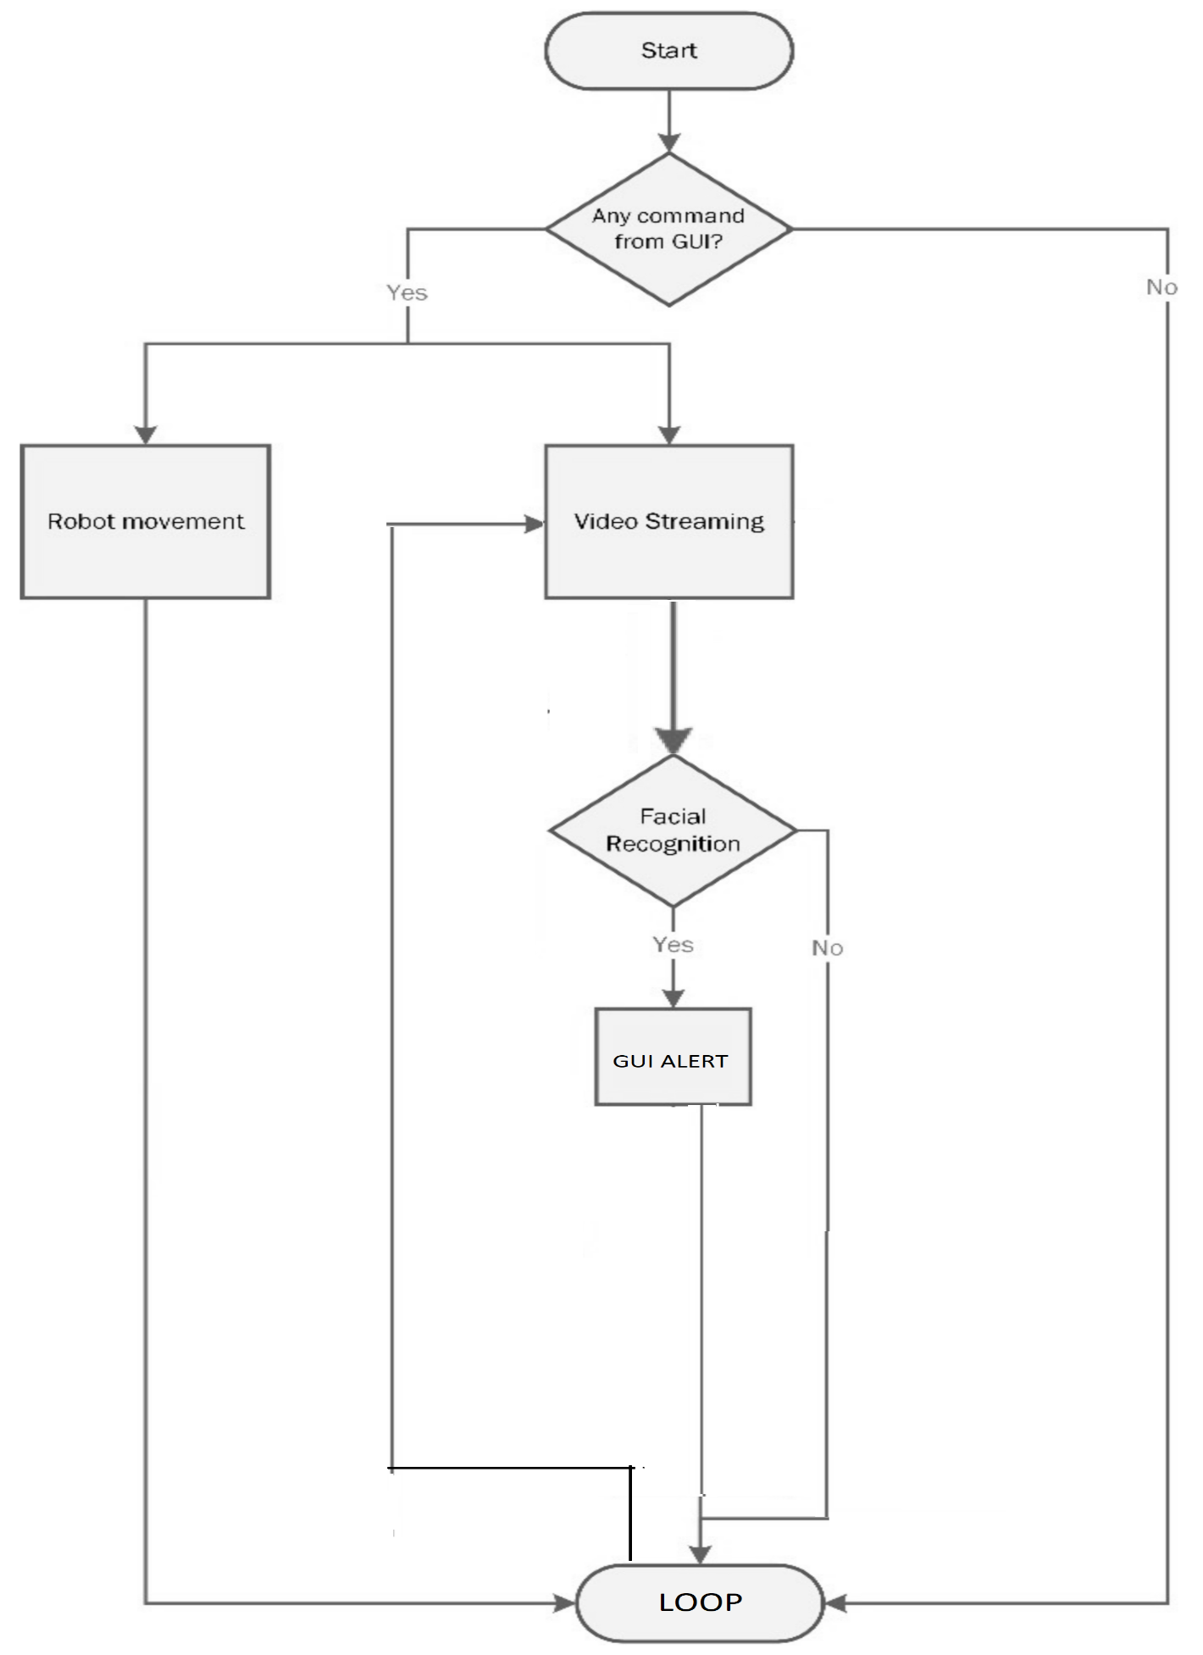

Figure 9 Flowchart

**CHAPTER 6: IMPLEMENTATION**

**6.1 Implementation Platform / Environment**

The implementation platform for this system depends on the specific requirements of the system and the resources available for development and deployment. Here are some possible implementation platforms:

1. **Breadboard:** A breadboard is a convenient platform for prototyping and testing the circuit design of the system. It allows for easy connections and modifications of the components and can be used for initial testing and validation of the system.
2. **Printed Circuit Board (PCB):** Once the circuit design is finalized, a PCB can be designed and manufactured to provide a more permanent and reliable implementation of the system. PCBs can be designed using software such as Eagle PCB and can be manufactured using various online services.
3. **Custom Enclosure:** To house the system and protect it from environmental factors, a custom enclosure can be designed and 3D-printed or machined. The enclosure can be designed using software such as Fusion 360 or SolidWorks and can be customized to fit the specific dimensions and components of the system.
4. **Microcontroller Development Board:** Arduino offers various development boards, such as the Arduino Uno or Arduino Mega, that provide a convenient platform for implementing the system. These boards already include the microcontroller, power supply, and various input/output pins that can be used for connecting the components of the system.

**6.2 Process / Program / Technology / Modules Specification(s)**

Here are the process, program, technology, and module specifications for the proposed surveillance system:

1. **Process specifications:**

* Image acquisition: The ESP32CAM camera module captures images and video frames of the surveillance area.
* Image processing: The OpenCV library processes the images and video frames to detect human intrusions using the YOLO detection algorithm.
* Alert generation: When a human intrusion is detected, the system generates an alert signal to notify the security personnel or trigger an automated response.

1. **Program specifications:**
   * Arduino IDE: The system is programmed using the Arduino IDE, which is an open-source integrated development environment for writing, compiling, and uploading code to Arduino boards.
   * OpenCV library: The system uses the OpenCV library for image processing and computer vision algorithms, including object detection, recognition, and tracking.
   * YOLO detection algorithm: The system employs the YOLO detection algorithm for real-time object detection and recognition, which is based on deep neural networks.
   * Alert generation: The system generates alerts using various mechanisms, such as sound alarms.
2. **Technology specifications:**
   * ESP32CAM camera module: The system uses the ESP32CAM camera module, which is an affordable, low-power camera module based on the ESP32 microcontroller.
   * WiFi connectivity: The ESP32CAM camera module provides WiFi connectivity, allowing the system to connect to the Internet and other devices.
3. **Module specifications:**
   * Image acquisition module: The ESP32CAM camera module provides the image acquisition module, which captures images and video frames of the surveillance area.
   * Image processing module: The OpenCV library provides the image processing module, which processes the images and video frames to detect human intrusions using the YOLO detection algorithm.
   * Alert generation module: The system provides the alert generation module, which generates alerts based on the detected human intrusions.

**6.3 Finding / Results / Outcomes**

The proposed surveillance system can have the following results and outcomes:

1. **Improved security:** The system can enhance security by detecting human intrusions in real-time and generating alerts to notify security personnel or trigger automated responses.
2. **Reduced costs:** The system can reduce the cost of surveillance by automating the detection process and eliminating the need for manual monitoring.
3. **Increased efficiency:** The system can increase the efficiency of surveillance by providing real-time monitoring and alerts, enabling security personnel to respond quickly to security breaches.
4. **Enhanced data analytics:** The system can provide valuable data analytics by storing and analyzing surveillance data, enabling security personnel to identify trends, patterns, and anomalies.
5. **Integration with other systems:** The system can be integrated with other security systems, such as access control, fire alarms, or CCTV systems, to provide a comprehensive security solution.

**CHAPTER 7: TESTING**

**7.1 Testing Plan / Strategy**

* + - 1. **Unit testing:** Unit testing involves testing each individual component of the system, such as the ESP32CAM camera module, OpenCV library, and YOLO detection algorithm, to ensure that they are functioning correctly.
      2. **Integration testing:** Integration testing involves testing the system as a whole, including the interaction between the different components, to ensure that they are integrated properly.
      3. **Performance testing:** Performance testing involves testing the system under different loads and scenarios, such as high traffic or varying lighting conditions, to ensure that it can handle the expected workload and perform reliably.
      4. **Security testing:** Security testing involves testing the system's ability to prevent and detect unauthorized access, such as hacking attempts or tampering with the surveillance data.
      5. **Usability testing:** Usability testing involves testing the system's user interface and user experience, to ensure that it is intuitive and easy to use for security personnel.
      6. **Acceptance testing:** Acceptance testing involves testing the system with the end-users, such as military personnel, to ensure that it meets their requirements and expectations.

The testing strategy can be divided into three phases:

1. **Development testing:** This testing phase occurs during the development of the system and focuses on the individual components of the system. Developers should perform unit testing and integration testing at this stage.
2. **System testing:** This testing phase occurs after the development of the system is complete, and the entire system is tested to ensure that it is functioning correctly. Testers should perform performance testing, security testing, and usability testing at this stage.
3. **Acceptance testing:** This testing phase involves testing the system with the end-users to ensure that it meets their requirements and expectations. Military personnel should be involved in this testing phase to provide feedback on the system's functionality and usability.

**7.2 Test Results and Analysis**

The following are the steps involved in test results and analysis:

* Record test results: All test results should be recorded and documented for future reference. The test results should include the test case, expected results, actual results, and any comments or observations.
* Analyze test results: After recording the test results, the next step is to analyze them to determine whether the system is meeting the requirements and specifications. The analysis should identify any discrepancies between the expected and actual results and document any issues or defects found during testing.
* Debugging and troubleshooting: Once the issues or defects have been identified, debugging and troubleshooting should be done to determine the root cause of the issue and find ways to fix it.
* Re-test: After debugging and troubleshooting, the system should be retested to ensure that the issues or defects have been resolved.
* Finalize the test report: Once all testing has been completed, a final test report should be created. The report should include a summary of the testing process, test results, and analysis, as well as any issues or defects found and how they were resolved.
* Continuous improvement: After completing the testing process, the results and analysis should be used to continuously improve the radar system. This can involve making changes to the system's design or code, updating the testing plan or process, or implementing new tools or technologies to enhance the testing process.

**7.2.1 Test Cases (test ID, test condition, expected output, actual output, remark)**

**Hardware system testing**

* A cable was used for connecting Arduino to develop developing machine. From Arduino IDE helped us to obtain result in serial monitor.

**GUI system design and implementation**

* GUI was build in python flask.

**Result**

Begin with uploading the code to Arduino after interfacing all the components and completing all the connections.

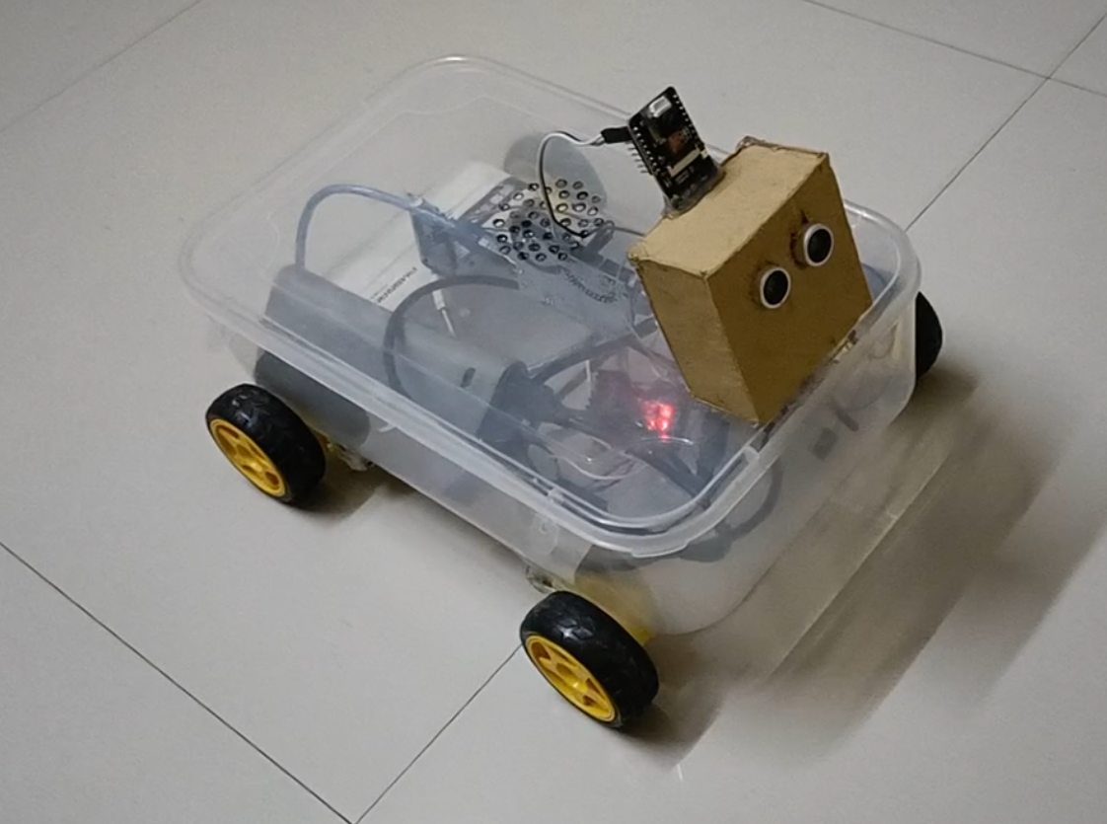

Figure 10 Surveillance Robot

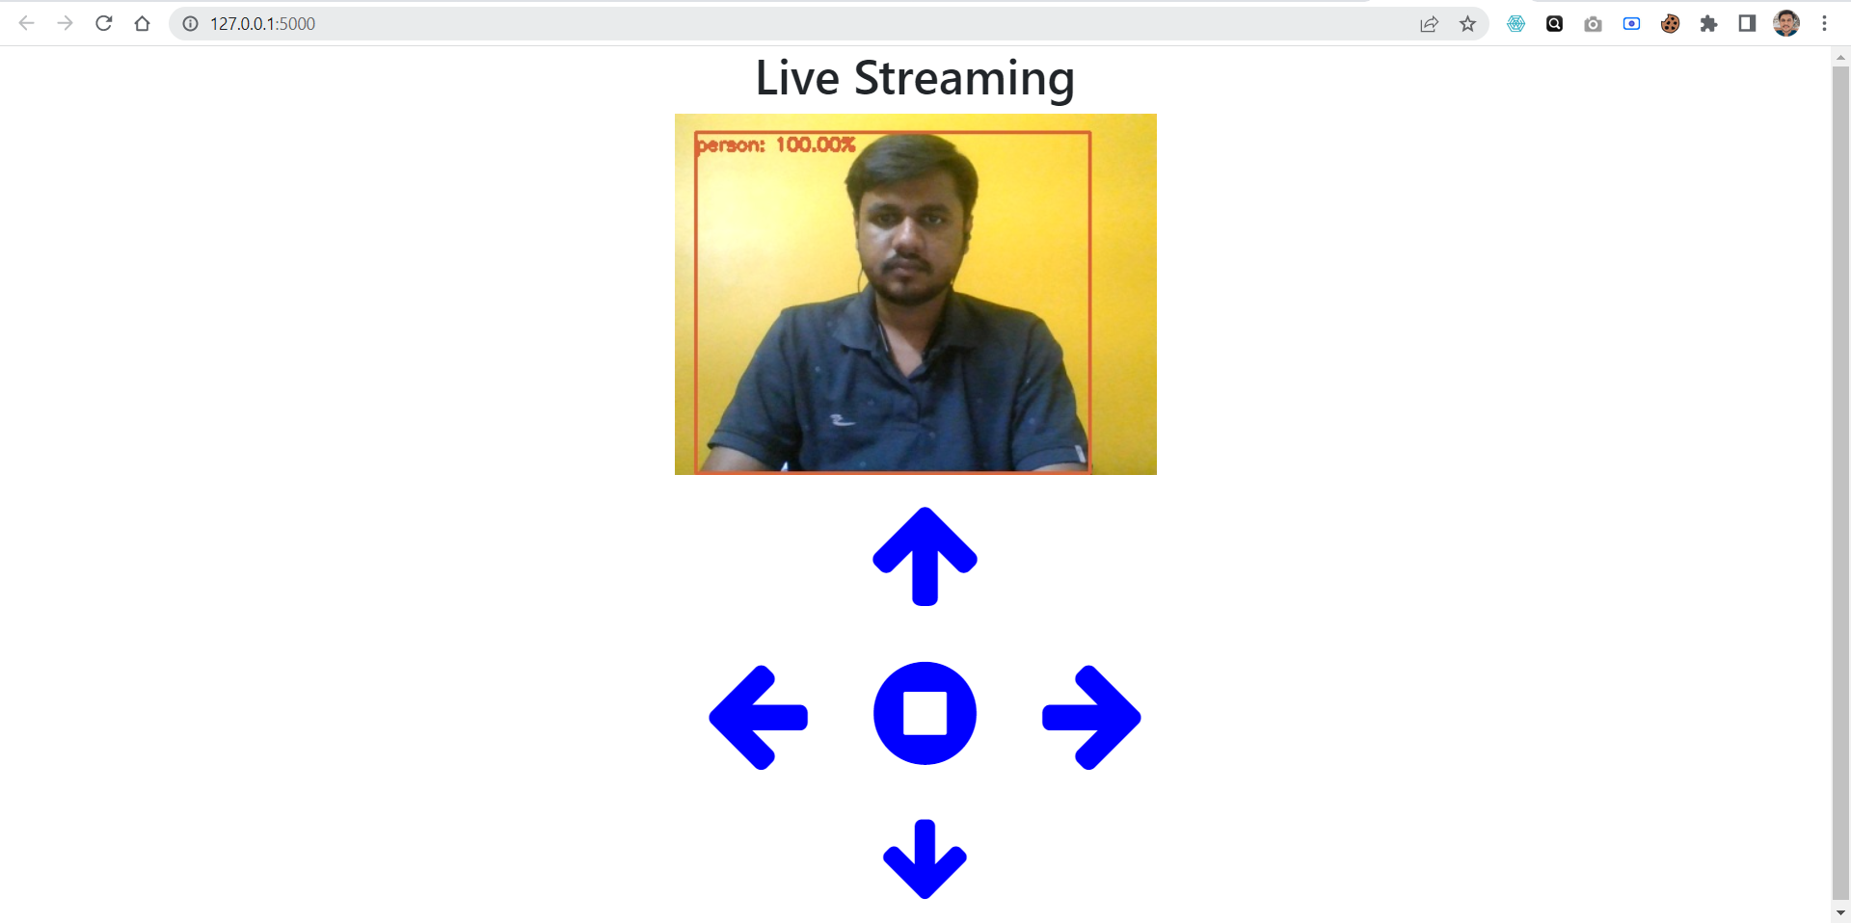

Figure 11 FLASK GUI

**CHAPTER 8: Conclusion and Discussion**

**8.1 Overall Analysis of Internship**

As an intern in the IoT department at Simform, I had the opportunity to develop a surveillance system for military purposes. During my internship, I gained hands-on experience with various hardware and software technologies, including microcontrollers, sensors, cameras, and machine learning algorithms.

**8.2 Dates of Continuous Evaluation**

1. **Continuous Evaluation – I** – 09/03/2023
2. **Continuous Evaluation – II** – 29/04/2023

**8.3 Summary of Internship**

Throughout my internship, I worked closely with my team lead and other senior engineers to plan and execute the project. We followed a structured approach to the development process, which included conducting a literature review, analyzing the current system, defining requirements, designing the system architecture, implementing the system, and testing it thoroughly.

I was responsible for developing the system's software components, including programming the ESP32CAM module and integrating it with the OpenCV and YOLO detection algorithm. I also contributed to the system design, testing, and documentation.

One of the most significant challenges I faced during the project was ensuring that the system was robust enough to handle real-world scenarios, such as varying lighting conditions and complex environments. To overcome this, I worked with my team lead to fine-tune the algorithm and optimize the system's performance.

Overall, my internship at Simform provided me with a valuable learning experience in the field of IoT and helped me develop practical skills in software development, system design, and project management. I gained insights into how a successful IoT project is planned and executed, and I was able to contribute to the development of a system that has real-world applications. I am grateful for the opportunity and look forward to applying the skills and knowledge gained from this experience to future projects.

**References**

1. "Intelligent Surveillance Robot with Obstacle Avoidance Capabilities Using Neural Network " by Pietro Arico.

Link - <https://www.hindawi.com/journals/cin/2015/745823/>

1. "Security Surveillance Robot" by SMP Robotics Systems Corp.

Link - <https://smprobotics.com/security_robot/security-surveillance-robot/>

1. "Design and Implementation Surveillance Robot Using ATmega328 Microcontroller" by Anas F Ahmed.

Link -

<https://www.researchgate.net/publication/329894828_Design_and_Implementation_Surveillance_Robot_Using_ATmega328_Microcontroller>